CNSL Lab Assignment 11
Neeti Kurulkar
Study and analyse the performance of HTTP, HTTPS, FTP protocol using Packet Tracer Tool.
- Network Topology
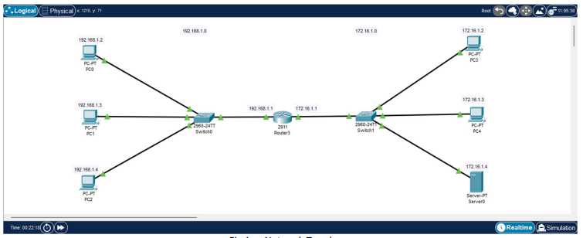

- IP Configurations of Server
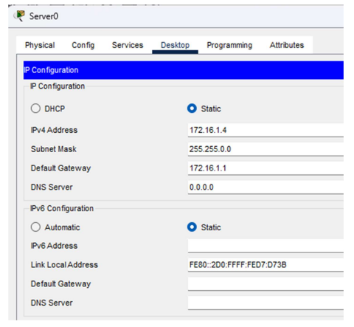

- Router Configurations 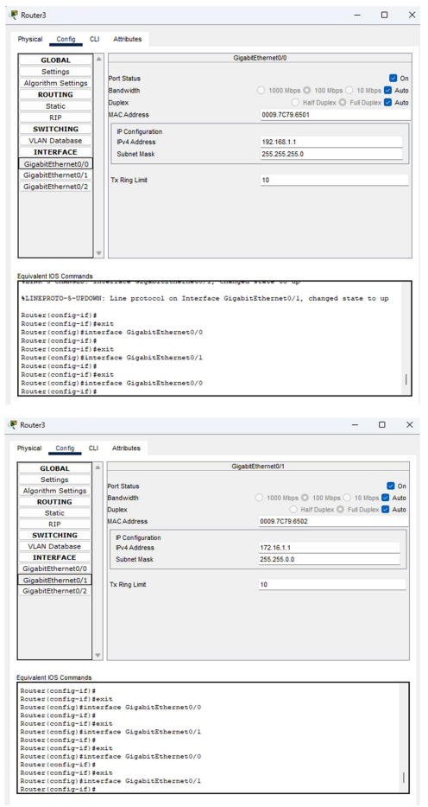
- Server FTP Service Fig
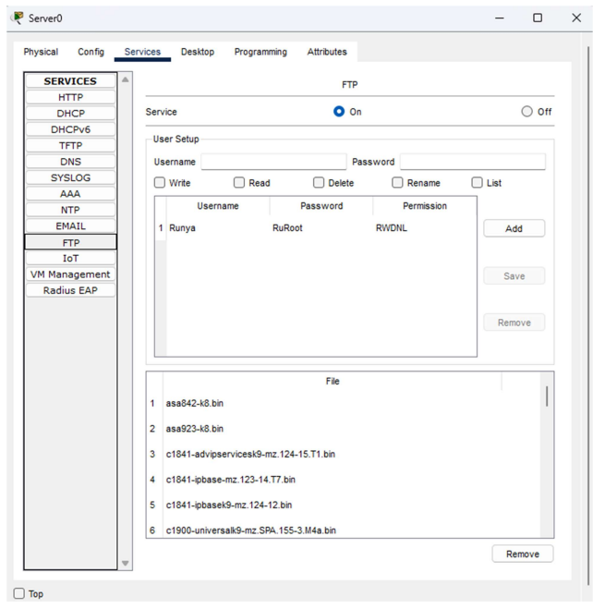

- Sending File from PC3 to Server
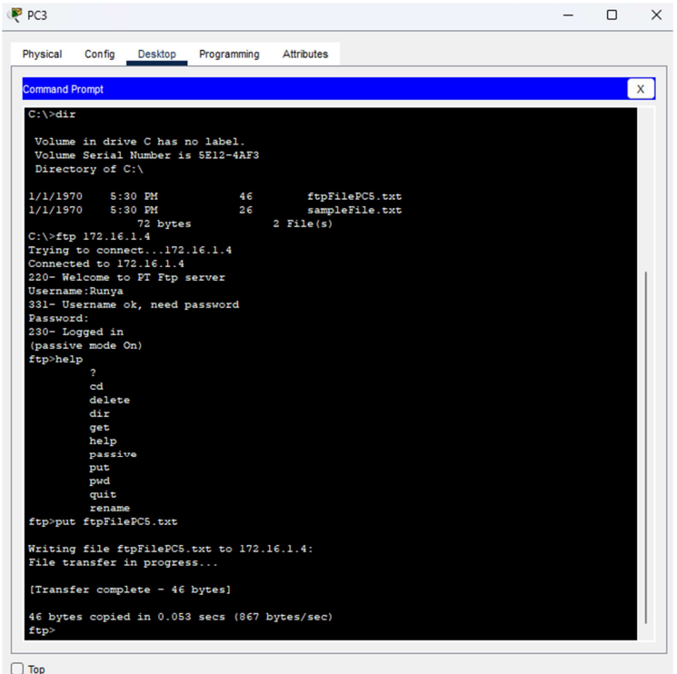

- Checking directory of Server for file sent from PC3.
